### **Knowledge Transfer (KT)Document: SRE**

#### Document Information

* Document Title: Overview Architecture of PEO, HRIS, DCP
* Version:1.1
* Date:15th Apr 2024 - 18th Apr 2024
* Prepared By: SRE-Coforge
* Reviewed By: Satya Akella (Coforge)

Table of Contents

**Knowledge Transfer(KT)Document : SRE** 1

Introduction 2

**1.1 Purpose of Document** 2

**1.2 Scope of KT** 2

**1.3 Intended Audience** 2

**1.4 Acronyms and Abbreviations** 2

2.Trinet Overview: 3

3. PEO Application: 3

**3.1 PEO Architecture Overview** 3

**3.2 Reference Architecture of PEO :** 3

**3.3 Technical Architechture of PEO** : 4

**3.3 Integration with PeopleSoft**: 5

**3.4 Third-Party Integration**: 5

**4.1 F5 Load Balancer:** 5

**4.2 Ms Web UI:** 5

**4.3 HA Proxy:** 5

**4.4 RabbitMQ :** 6

**4.5 REDIS-CACHE** 8

5. HRIS Application 10

**5.1 ASO Platform Overview:** 10

**5.2 Architecture for ASO platform (HRIS)**: 11

**5.3 Technology Stack**: 12

**6.4 key URL’s :** 12

6. Danille Customer Platform (DCP) : 12

**6.1 Technology Stack**: 12

**6.2 Reference Architecture :** 13

**6.2 Technical Architecture :** 13

**6.3 key URL’s :** 13

## Introduction

### **1.1 Purpose of Document**

This document serves the purpose of Overview of architectures of PEO, HRIS and DCP its components & configurations.

### **1.2 Scope of KT**

The scope is to cover detailed understanding of critical application architecture of PEO and its components.

### **1.3 Intended Audience**

SRE – Coforge Team

SRE – Trinet Team

### **1.4 Acronyms and Abbreviations**

|  |  |
| --- | --- |
| Acronym | Full Form |
| PEO | Professional Employer Organization |
| WSE | Work Site Employee |
| ASO | Administrative Service Offering |
| HRIS | Human Resource Information System |
| OCI | Oracle Cloud Infrastructure |
| API | Application Program Interface |
| UI | User Inferface |
| DCP | Denile Customer Platform |
| GTM | Global Traffic Manager |
| LTM | Local Traffic Manager |
| UI | User Inferface |
| AMQP | Advances Messaging Queue Protocol |

## **2.Trinet Overview**:

TriNet is a of HR outsourcing solution with major functionalities Payroll and Medical benefits

* TriNet operates in below major segments:
* Professional Employer Organization (PEO): Assumes employer responsibilities, including liability for worksite employees.
* Administrative Services Organization (ASO): Provides HRIS services, acquired through Zenefits.
* Developing DCP (Denali Customer Platform) to support both PEO and ASO.
* Other acquired platforms include Cloud Apps Platform and Claurus R&D, all hosted on AWS.

## **3. PEO Application**:

* PEO is also called as HR Passport for External Customers. It is a digital platform used by organisations for managing human resources tasks such as Employee Onboarding, Performance management , Payroll, Benefits and Compliance.

### **3.1 PEO Architecture Overview**

* It is developed on OCI and Accessed by end-user employees via mobile/browser apps, business applications (APIGEE), employers/vendors via API gateway, by using OKTA authentication & authorization.
* Requests directed through Global Traffic Manager (GTM) based on routing policies, the request will be directed respective webservers.
* Webservers built on AngularJS and Java. The request goes through a firewall and Local Traffic Manager (LTM) for HR passport service and goes through HAProxy and another LTM for ingress.
* Now the request will hit k8s cluster. It has two clusters an active and passive respectively.
* APIs interact with Oracle Exadata DBs (HR Passport DB and PeopleSoft DB).
* Redis used for memory caching, RabbitMQ for messaging between APIs and external clusters.
* For HIP (Hybrid Informatica) for reporting.

### **3.2 Reference Architecture of PEO :**

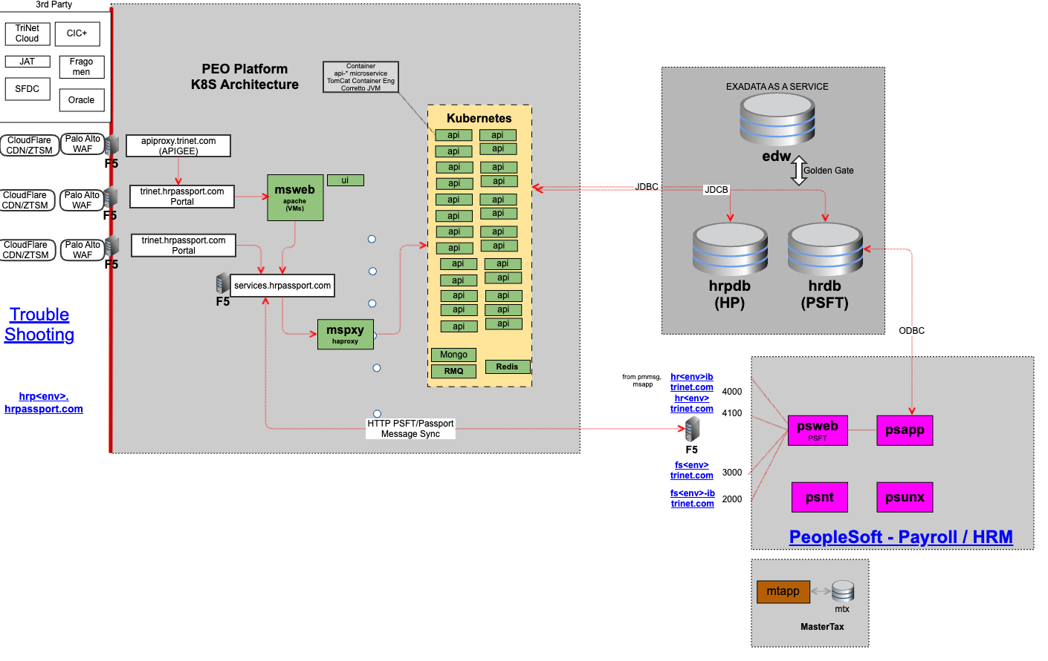

### **3.3 Technical Architechture of PEO** :

### **3.3 Integration with PeopleSoft**:

* PEO communicates with PeopleSoft for payroll processing.
* Web and application servers along with HRDB (for PeopleSoft) deployed.
* Special API written and run in Kubernetes cluster to bridge messaging with RabbitMQ due to PeopleSoft's legacy architecture.

### **3.4 Third-Party Integration**:

* PEO interacts with various third-party tools like i9 services , salesforce, DocuSign, box through external links.

* 1. **Components of PEO**

### **4.1 F5 Load Balancer:**

* Positioned before the Microsoft Web UI servers, the F5 Load Balancer serves as a Global Traffic Manager (GTM).
* It directs incoming requests to the appropriate servers based on load balancing algorithms. Furthermore, the F5 Load Balancer enhances security by enabling HTTP to HTTPS redirection and conducts health checks to ensure server availability.

### **4.2 Ms Web UI:**

* Ms Web UI servers host static content and UI code for the PEO application.
* Apache Httpd (Hypertext Transfer Protocol Daemon) is used as the web server software on these servers.
* Apache Httpd serves HTTP and HTTPS content and also acts as a reverse proxy.
* The servers are part of a load-balanced pool behind an F5 Big-IP device, which handles load balancing and some security features like HTTP to HTTPS redirection.
* Health checks are performed by the F5 device to ensure that traffic is only routed to healthy servers.

### **4.3 HA Proxy:**

* HA Proxy is used as a reverse proxy and load balancer.
* It analyzes incoming HTTP traffic and routes requests to the appropriate backend application based on the request content.
* HA Proxy also performs load balancing based on its own algorithms and heuristics.
* It has a configuration file (haproxy.cfg) where backend APIs and health checks are defined.
* HA Proxy monitors the health of backend services and forwards traffic only to healthy instances.

### **4.4 RabbitMQ :**

**4.4.1 Introduction to RabbitMQ:**

* **RabbitMQ** is a message broker software that enables communication between applications, services, or systems by allowing them to exchange information in the form of messages.
* It acts as a middle layer, decoupling application components and storing messages in queues until they are consumed by the intended recipients.
* RabbitMQ facilitates scalability and performance by distributing message processing across multiple consumers.

**4.4.2 Components of RabbitMQ:**

* **Producer**: Originates requests and sends them to exchanges.
* **Exchange**: Receives messages and distributes them based on predefined rules to queues.
* **Routing keys**: It describes the payload on the RabbitMQ messaging system to determine who will receive the copy of the message.
* **Binding**: Links exchanges with queues, using routing keys to determine message routing.
* **Queue**: Stores messages until they are consumed by consumers.
* **Consumer**: This component receives the messages from RabbitMQ queue.
* A diagram of a cloud

  Description automatically generated

**4.4.3 TriNet Integration:**

* TriNet utilizes RabbitMQ for its clustered environment, where it manages two primary databases: HR and HP.
* Updates to employee profiles trigger requests sent to the API employee, which are then distributed to multiple queues based on the type of update.
* Example queues include platform exchange and PeopleSoft exchange, each serving specific purposes in updating the corresponding databases.
* The integration ensures that changes made in TriNet's platform reflect accurately in both the application layer and the PeopleSoft layer.
* The latest RabbitMQ protocol (AMQP) is not supported by Peoplesoft application due to lack of updates.
* To rectify the above issue, there is a customized API which converts and send the message to peoplesoft application which is in understandable format.

**4.4.4 Architecture of RabbitMQ :**

**4.4.5 Infrastructure and Console Overview:**

* A console provides an overview of nodes, connections, channels, exchanges, and queues, allowing administrators to monitor and manage RabbitMQ functionalities.
* The console offers insights into message details, including publishers, routing keys, and queue consumers, which helps in troubleshooting if in case of any incidents.

**4.4.6 Start and Stop Procedures of RabbitMQ:**

* RabbitMQ nodes should be started and stopped in a specific order to maintain cluster integrity.
* Jenkins jobs are used for automated start and stop procedures, ensuring consistency across environments.
* Detailed runbooks provide step-by-step instructions for starting, stopping, and configuring RabbitMQ on new servers.

### 

### **4.5 REDIS-CACHE**

Caching is the process of storing data in cache which is a temporary   Storage area that facilitates faster access to data with the goal of improving application and system  performance.

#### **4.5.1 Redis Caching:**

* Redis caching significantly improves application performance by storing frequently accessed data in memory.
* This results in reduced throughput and Input/Output Operations Per Second (IOPS) on backend systems, leading to smoother user experiences.

#### **4.5.2 Redis  cluster  at TriNet**:

* TriNet utilizes Redis for two separate Nodes , employing standalone and clustered setups based on environment requirements and cost considerations.
* Redis serves as an in-memory data store, housing separate databases for pre-login and post-login data.

#### **4.5.3 Functionality of Redis Caching**:

* The pre-login database stores data crucial for the login experience, such as menu items, while the post-login database handles data for interactions after login, like viewing benefits.
* A cache interceptor mechanism checks for data in Redis upon user requests.
* If the requested data is found in Redis (cache hit), it's retrieved directly, bypassing backend calls.
* If the data is not found (cache miss), the request proceeds to the backend, and the retrieved data is stored in Redis for future use.

#### **4.5.4 Benefits and Cost Reduction**:

* Caching leads to improved application performance, reduced backend load, and subsequently, reduced database costs.
* Without caching, frequent database calls result in high throughput and IOPS, necessitating expensive scaling.
* With Redis caching in place, the strain on backend systems is minimized, enabling potential cost savings.

#### **4.5.5 Databases in Redis:**

**4.5.5.1 Pre login**

* The pre-login Redis database at TriNet serves the purpose of storing data that is required to facilitate a smooth and efficient login experience for users accessing the TriNet platform.

**4.5.5.2 Post login**

* The post-login Redis database at TriNet is designed to store data that is frequently accessed after a user has successfully logged into the TriNet platform.

**4.6 Key URL’s :**

OCI Network architecture: <https://confluence.trinet-devops.com/display/PUBCLOUD/OCI+Network+Architecture​>

Greenstack application Overview :[https://confluence.trinet-devops.com/display/prodready/Greenstack+-+Application+Overview​](  %20https:/confluence.trinet-devops.com/display/prodready/Greenstack+-+Application+Overview​)

RabbitMQ confluence page : <https://confluence.trinet-devops.com/display/prodready/RabbitMQ+-+Console+URLs>

## **5. HRIS Application**

* HRIS (Human Resource Information System) application is an integrated software solution designed to streamline and automate various HR functions that helps organisations manage various aspects of HR functions including Employee data management, Payroll.
* It serves as a centralized database to store, manage, and process employee-related information.
* This platform is also being called as ASO platform .

### **5.1 ASO Platform Overview:**

* ASO stands for Administrative Service Offering, another client/customer-facing platform within TriNet.
* Hosted entirely on the AWS platform, utilizing ECS (Elastic Container Service) clusters.

### **5.2 Architecture for ASO platform (HRIS)**:

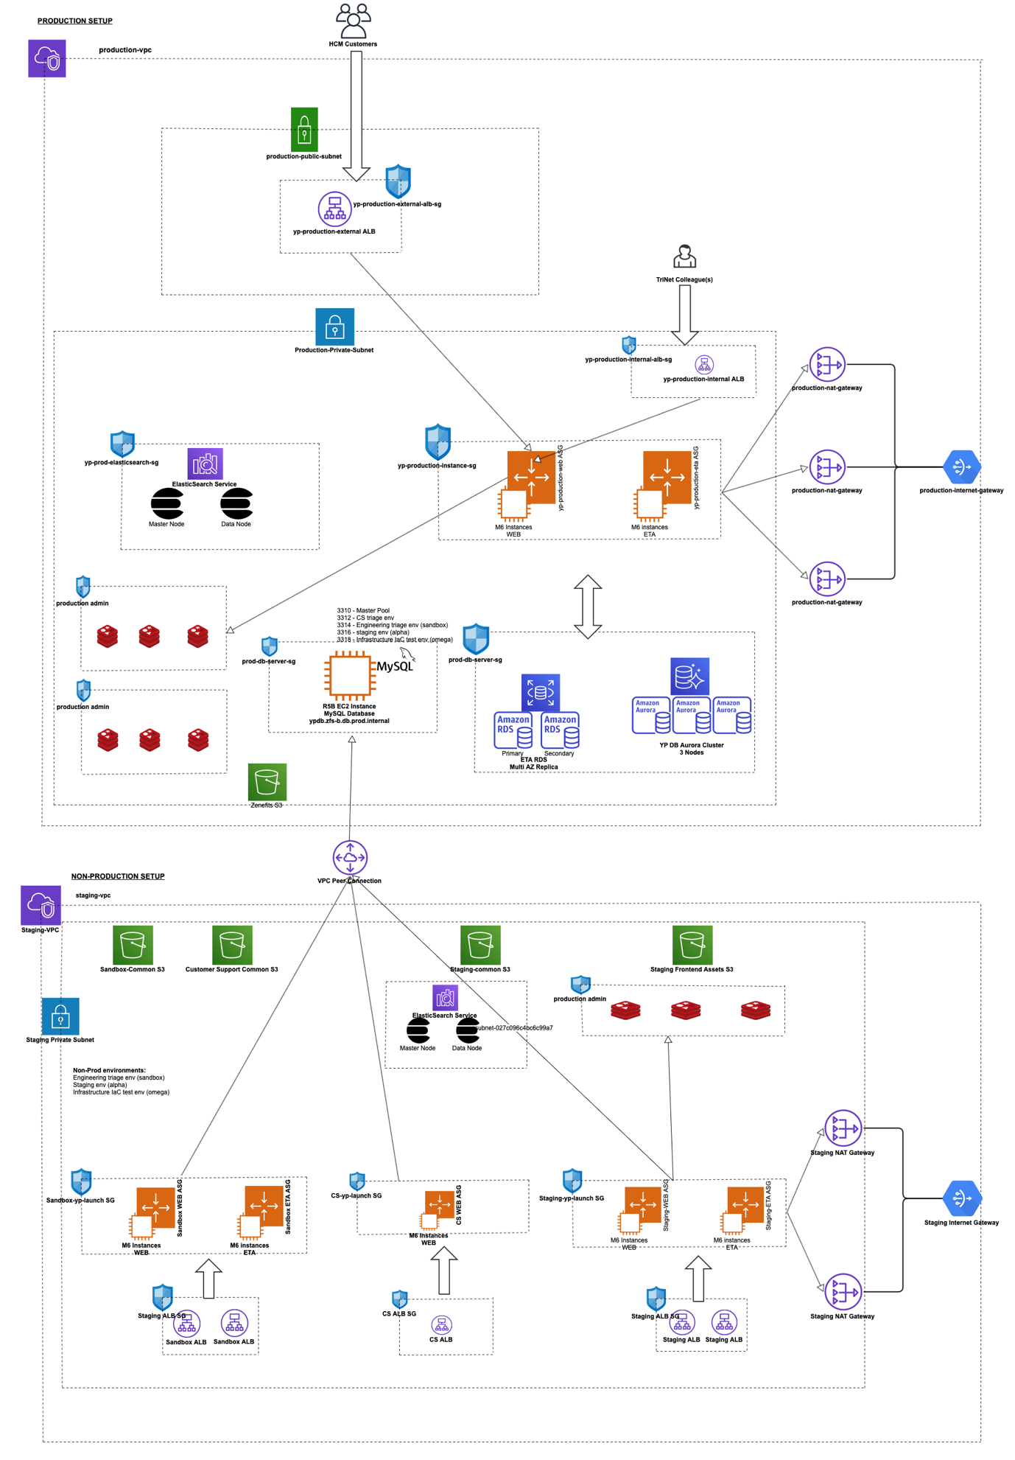

### **5.3 Technology Stack**:

* Frontend developed using Python Django Framework .
* UI Services employ Amber and ReactJS .
* Backend API Services built with Python Django framework.
* Database infrastructure includes MySQL and RDS Aurora.

### **6.4 key URL’s :**

Confluence page for HRIS platform :

<https://confluence.trinet-devops.com/display/ZENG/Production+Fleet>

Overall, the ASO platform employs a modern technology stack with Python Django and React JS for both backend and frontend development, respectively. It utilizes AWS services such as ECS for hosting, RDS Aurora for database management, and Redis for caching to enhance system performance.

## **6. Danille Customer Platform** **(DCP)** :

It is developing to merge the existing features of both PEO & HRIS applications as a single platform using AWS services.

### **6.1 Technology Stack**:

* Java , JavaScript , Python.
* RDBMS , NoSQL

DCP is intended to integrate the best features of PEO and HRIS

Applications. If any of the service is suitable with updated cloud features. TriNet is expecting them to Lift and Shift.

### **6.2 Reference Architecture :**

### **6.2 Technical Architecture :**

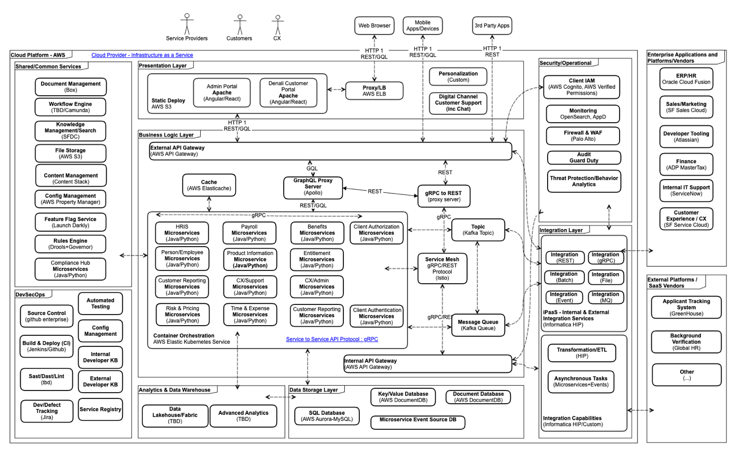

### 

### **6.3 key URL’s :**

Confluence page for DCP platform :

<https://confluence.trinet-devops.com/display/DCP/Denali+Customer+Platform>

**Overall, DCP is a new platform that is being developed by TriNet to have the best features from both PEO and HRIS platforms.**